A video store uses the following table to keep track of movies.

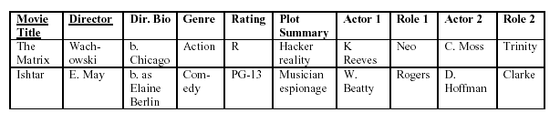

Can you suggest a better primary key to uniquely identify a movie? (Ok to add

attributes)

Which normal forms are violated?

Anomalies?

Data structure diagram? 1NF and then 2NF.